Experiment 4: Vacuum Cleaner Problem
Aim:
To write a Python program for the Vacuum Cleaner problem.

Objective:
- To understand the Vacuum Cleaner problem.
- To clean all dirty rooms.
- To display the status of each room after cleaning.
- To understand the working of a simple intelligent agent.

Algorithm:
- Start the program.
- Read the status of Room A and Room B.
- Check whether Room A is dirty.
- If dirty, clean Room A.
- Check whether Room B is dirty.
- If dirty, clean Room B.
- Display the final status of both rooms.
- Stop the program.

Pseudocode:
START
Read Room A status
Read Room B status
IF Room A is Dirty
Clean Room A
IF Room B is Dirty
Clean Room B
Display Room A status
Display Room B status
STOP

Program:
roomA = input("Enter Room A status (Dirty/Clean): ")
roomB = input("Enter Room B status (Dirty/Clean): ")
if roomA == "Dirty":
print("Cleaning Room A...")
roomA = "Clean"
if roomB == "Dirty":
print("Cleaning Room B...")
roomB = "Clean"
print("\nFinal Status")
print("Room A :", roomA)
print("Room B :", roomB)

Input:
Enter Room A status (Dirty/Clean): Dirty
Enter Room B status (Dirty/Clean): Clean

Output:
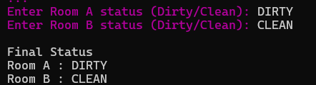

Result:
Hence, the Python program for the Vacuum Cleaner Problem was executed successfully.

